Francisco Rois Siso

A20385948

04/28/2017

Final Project- ITMD510 Object-Oriented Application Development

Points Store

**Content**

1. Program description.
2. Snapshots and detailed explanations.
3. **Program description.**

The program is a store in which users can register, login, invest in products and buy them with points, and other store-related functionalities.

There are four types of users:

* **Regular User:** can buy products from market type 1 and sees regular advertisements.
* **Semipremium User:** can buy products from market type 2 and sees semipremium advertisements.
* **Premium User:** can buy products from market type 3 and does not see any advertisements.
* **Admin:** can see all the types of markets together and does not see advertisements.

The program allows users to register in the databases, login into the system by introducing the correct data, see the market that corresponds to his type of user, invest points on products, add products to the order, and also the user can save the data from the investments he made on the market in order to recover it the next time he logs into the system. Moreover, he can delete the saved data from a previous market, so when the user comes back to the market it is restored.

The application makes use of 5 tables on the database, performing all the needed CRUD operations for their entities:

* **f_rois_users4:** stores all the information from the users previously registered in the system, including their username and password.
* **f_rois_markets:** stores the different types of markets that are available in the system, and their features.
* **f_rois_updated_markets2:** this table is meant to store the data saved from a market, when a user decides to save the current version of the market for future visits to the system.
* **f_rois_products:** table with all the available products in the system, including fields such as the product id and the type of market which they are attached to.
* **f_rois_orders2:** each of the registers on this table shows the orders made and the user that made them. Each includes a list of the product ids that are in the order.

Users and passwords for testing:

* ***Username:*** regular  
  ***Password:*** pass
* ***Username:*** semipremium  
  ***Password:*** pass
* ***Username:*** Premium  
  ***Password:*** pass
* ***Username:*** admin  
  ***Password:*** admin

1. **Snapshots and detailed explanations.**

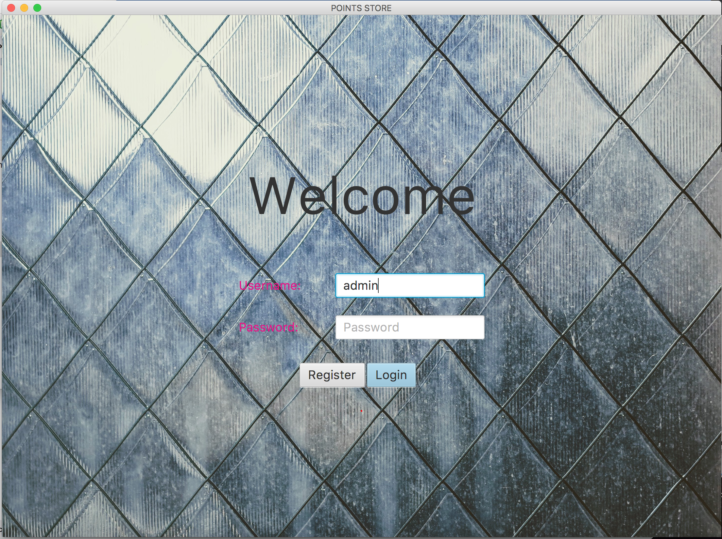

*Welcome screen. The user can insert the credentials and press Login. If the credentials are not correct, the user is alerted.*

*Clicking on the Register button, the Registration window is displayed.*

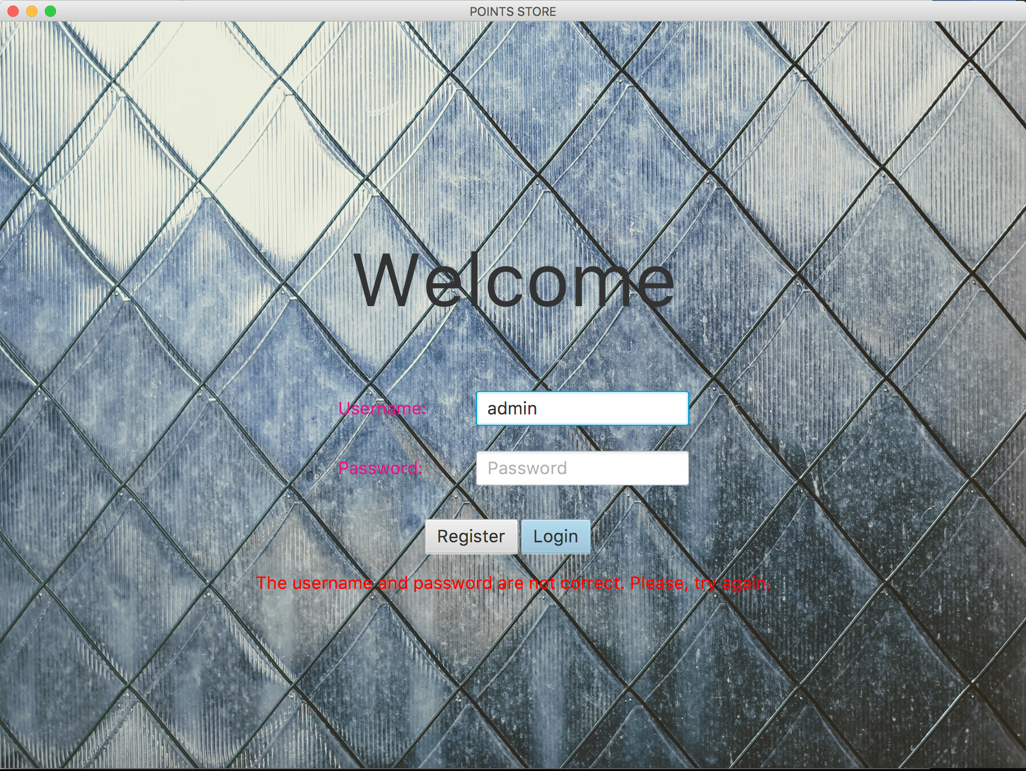

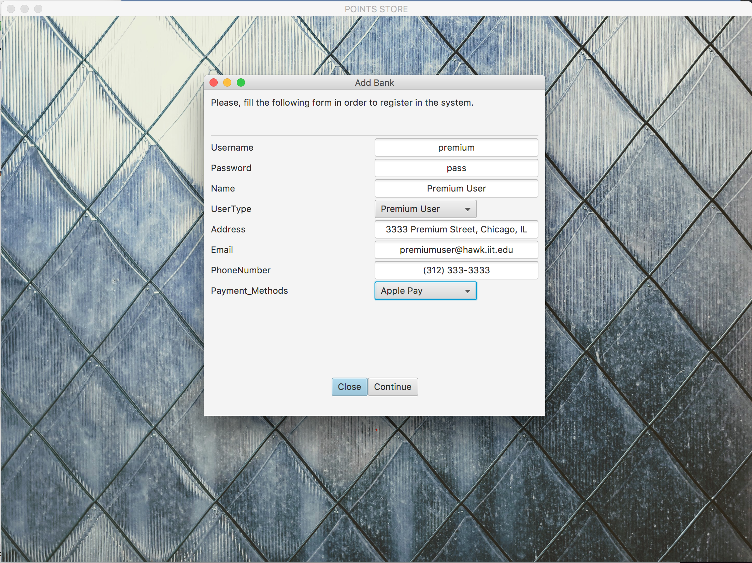

*The user can register by filling in the form and clicking on Continue. A message is displayed when the registration process is successful. The button Close will close the window.*

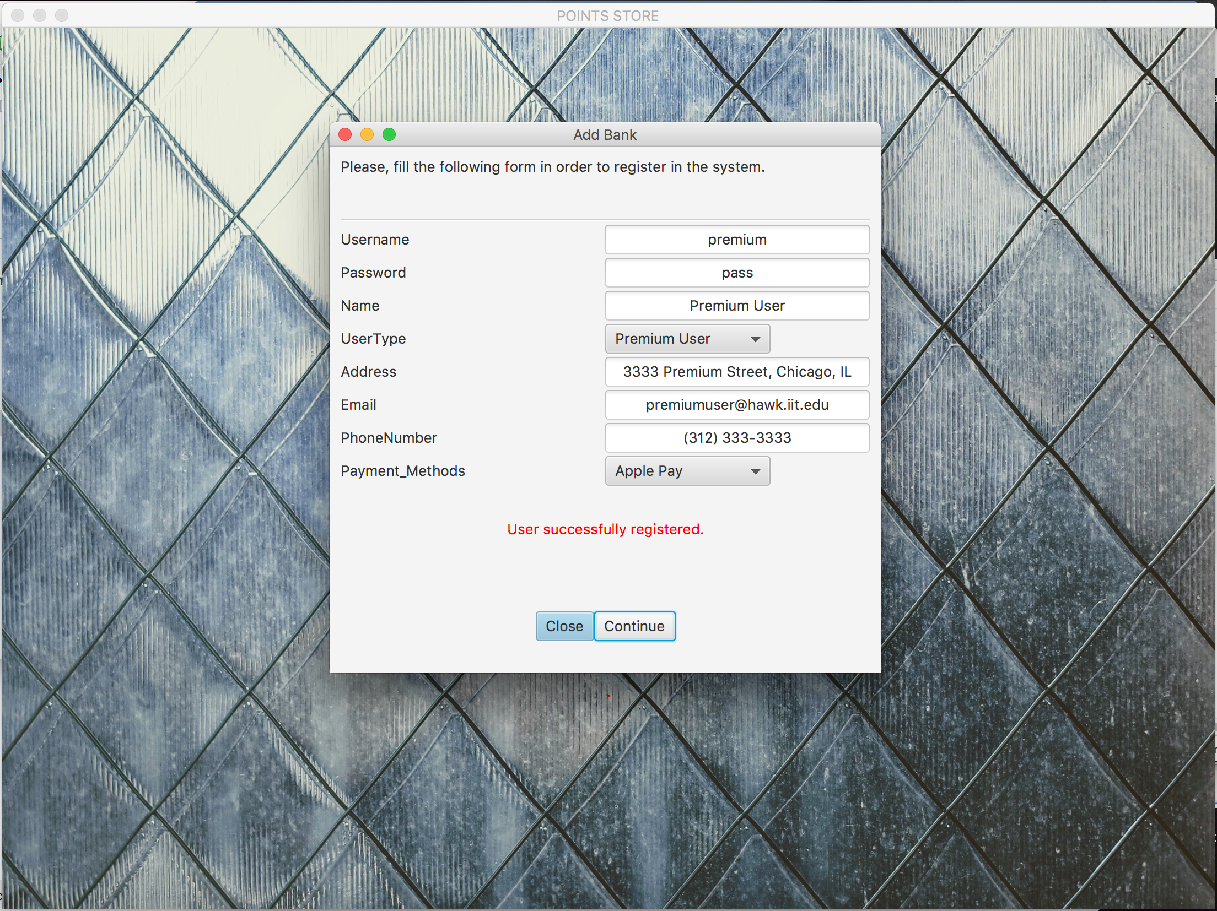

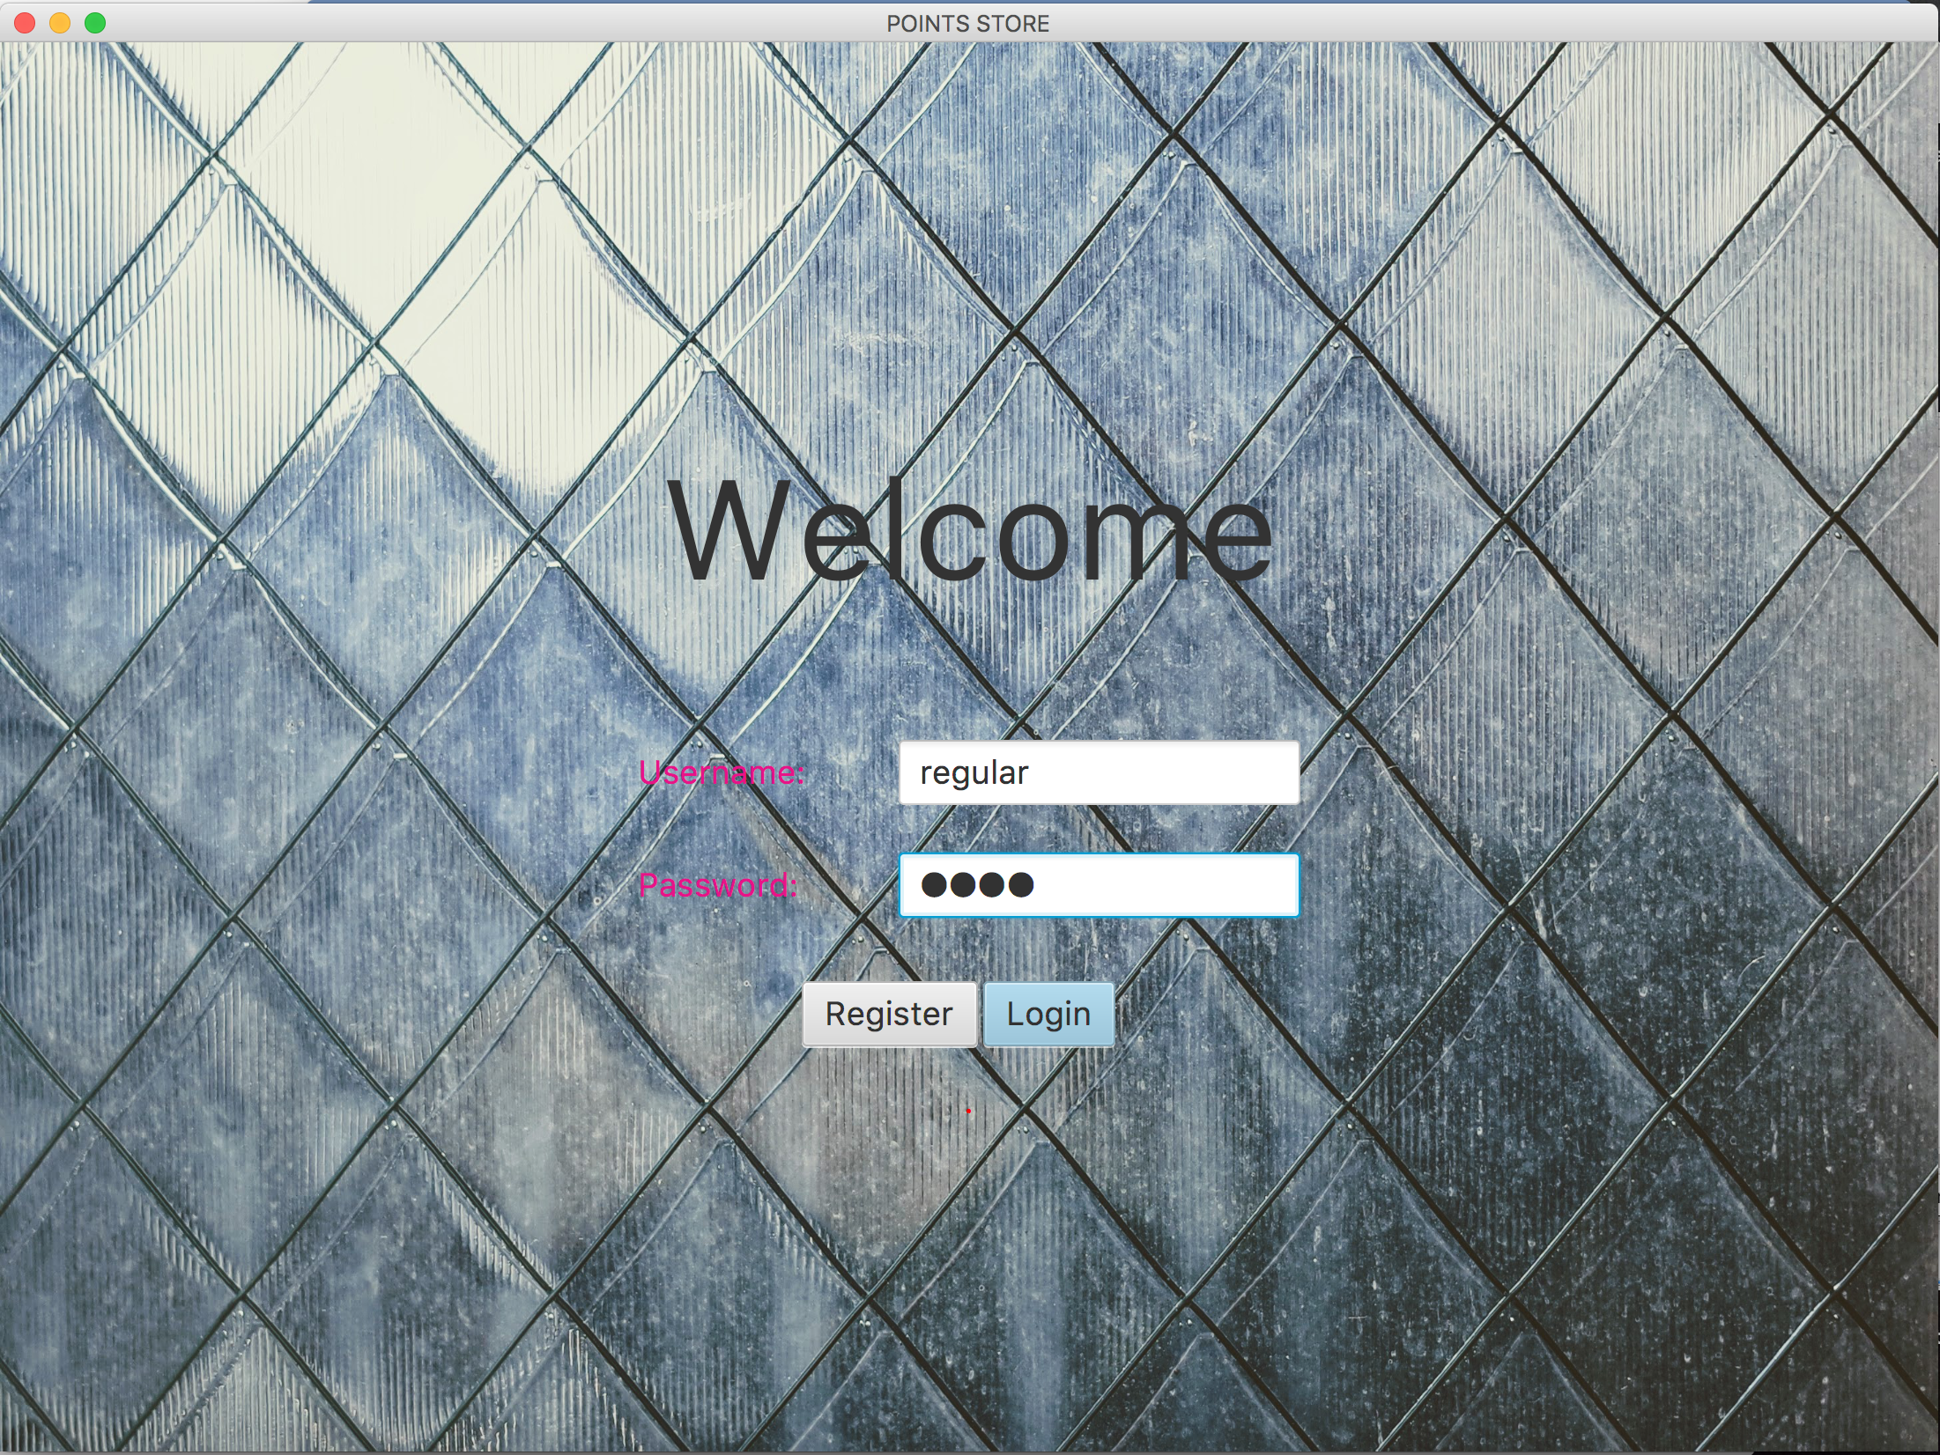

*As an example, a regular user access the system. (Username: regular , Password: pass)*

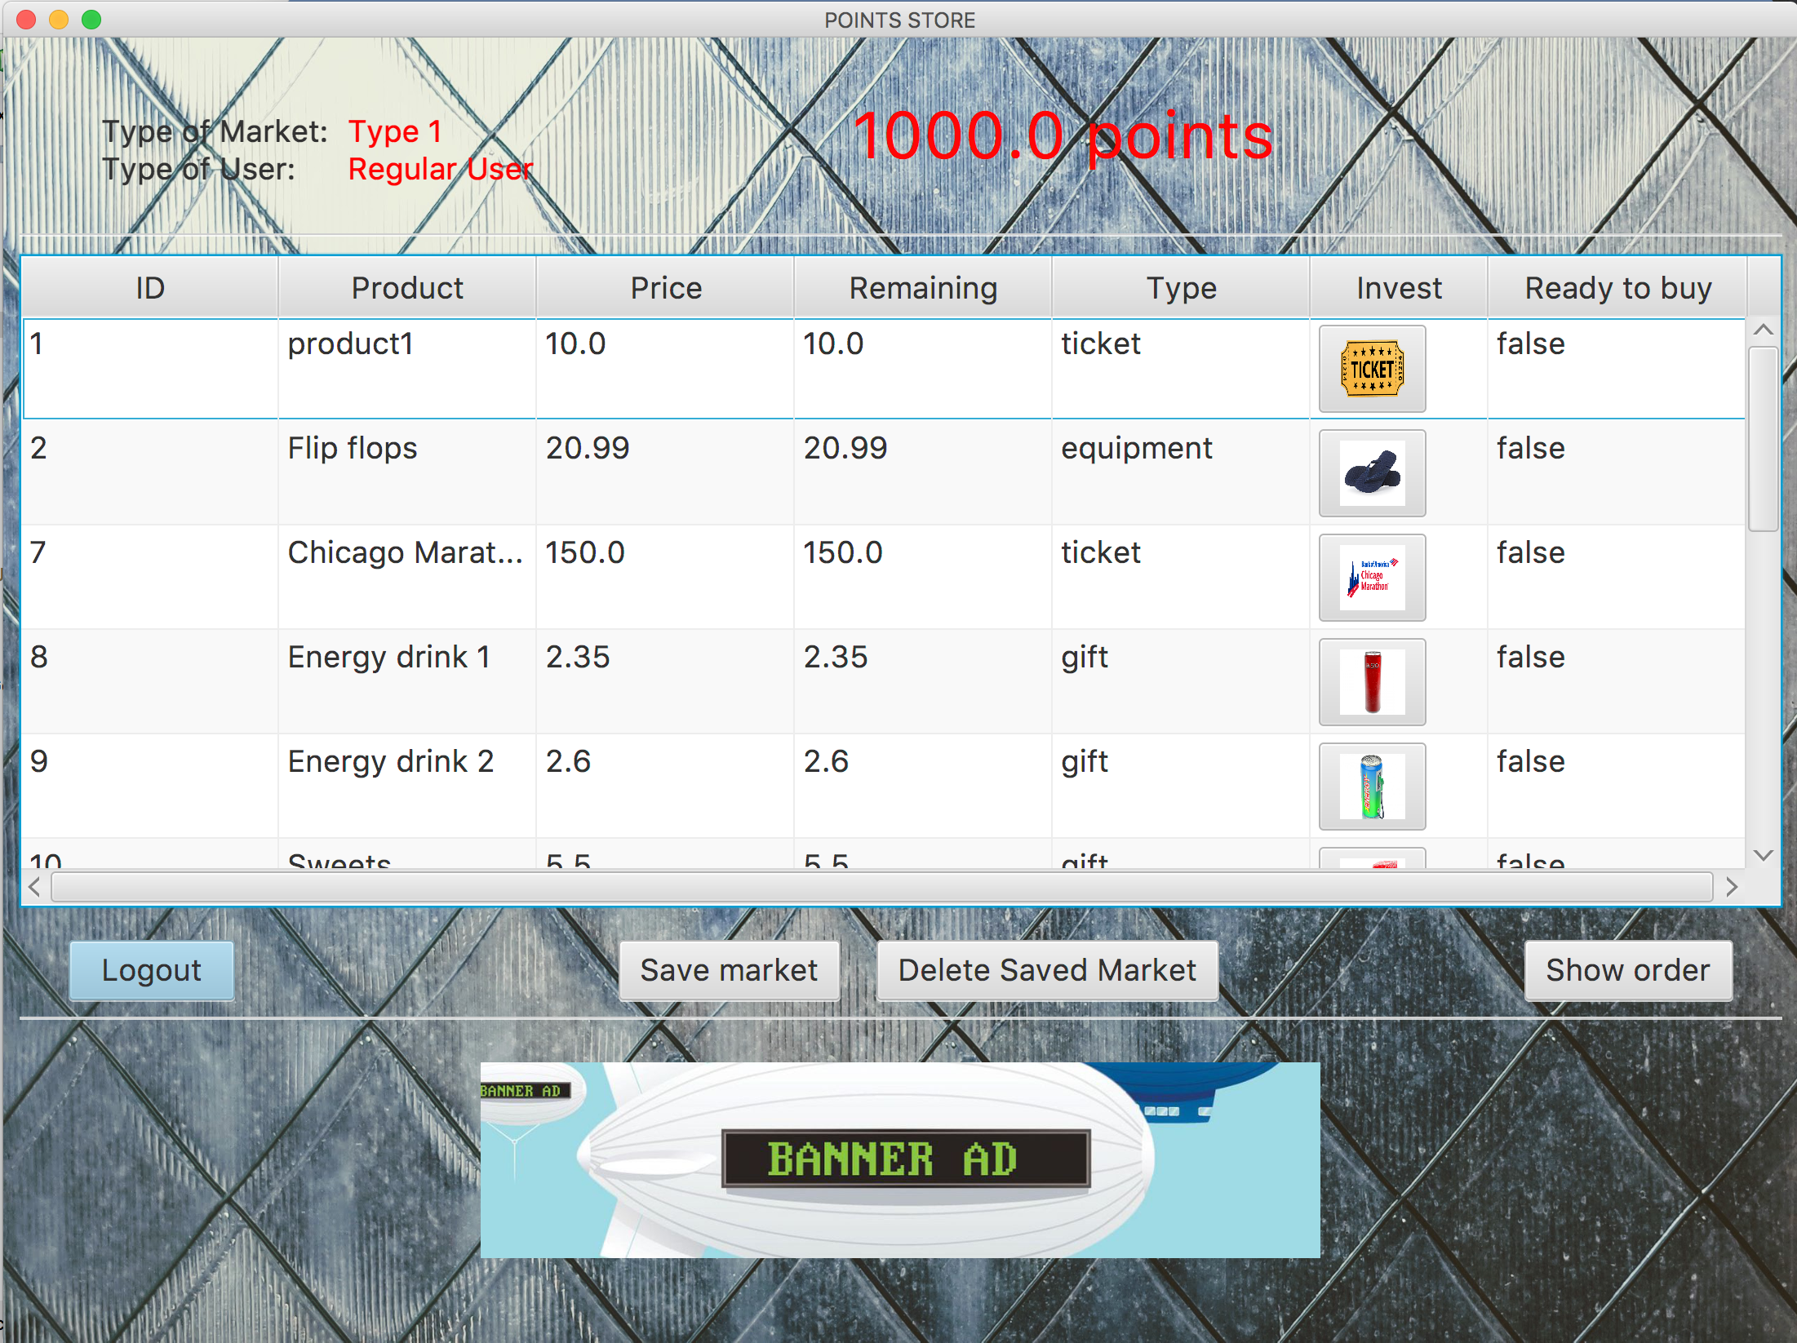

*A market of type 1 is displayed, showing the products for the market that the particular user is allowed to see. On the top is displayed the type of user and market, and a big number showing the points that the user has, and which he can invest in products.*

*In the middle part is the market. It shows the available products and their data. It is shown the price and the remaining amount that the user needs to pay of the product in order to add it to the order.*

*There is a column showing false or true depending of the product being ready to add to the order or not. This column shows true only in the case that a particular product’s remaining amount is already zero.*

*Below the market, there are four buttons.*

* *Logout: logs out of the system and goes to the welcome login window.*
* *Show order: shows a new window with the order’s information and status.*
* *Save market: clicking this button, the user saves the market, so the next time that the same user logs into the system, the saved market is displayed, with the correspondant investments.*
* *Delete Saved Market: the user can use this button to delete the previously saved market from the database, so the next time that he logs into the system, all the products in the market are restored and the market is reset.*

*The final element on the screen is a banner add. Only certain user types see ads (Regular and Semipremium Users), and every ad is particularized to the type of user that is logged into the system. The image shows a banner for a regular user.*

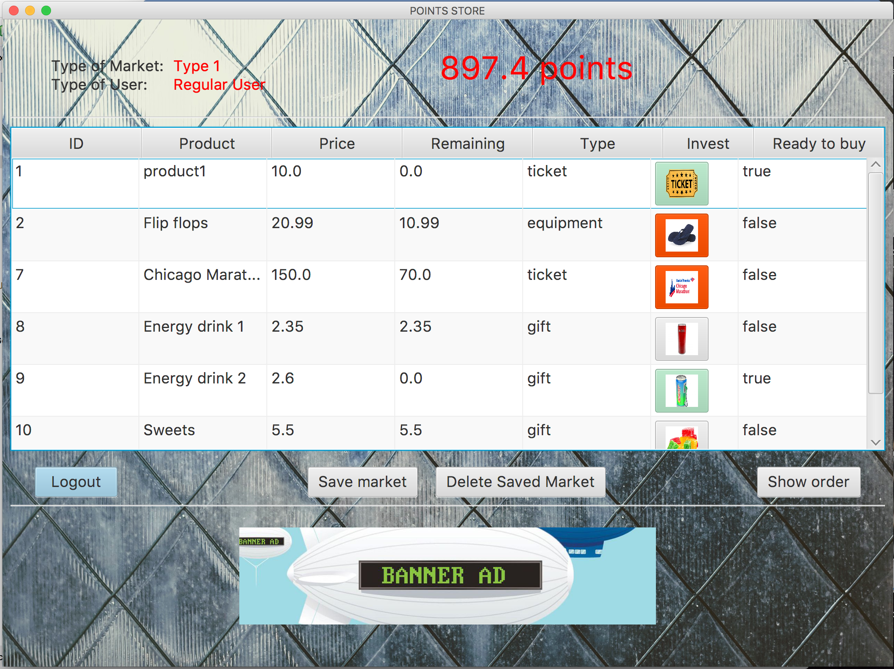

*The user can invest in products by clicking on their images. While a product is not totally payed yet, the button showing the image remains red. When the item is totally paid and therefore ready to be added to the order, the button turns to green and the “Ready to buy” column changes to “true”.*

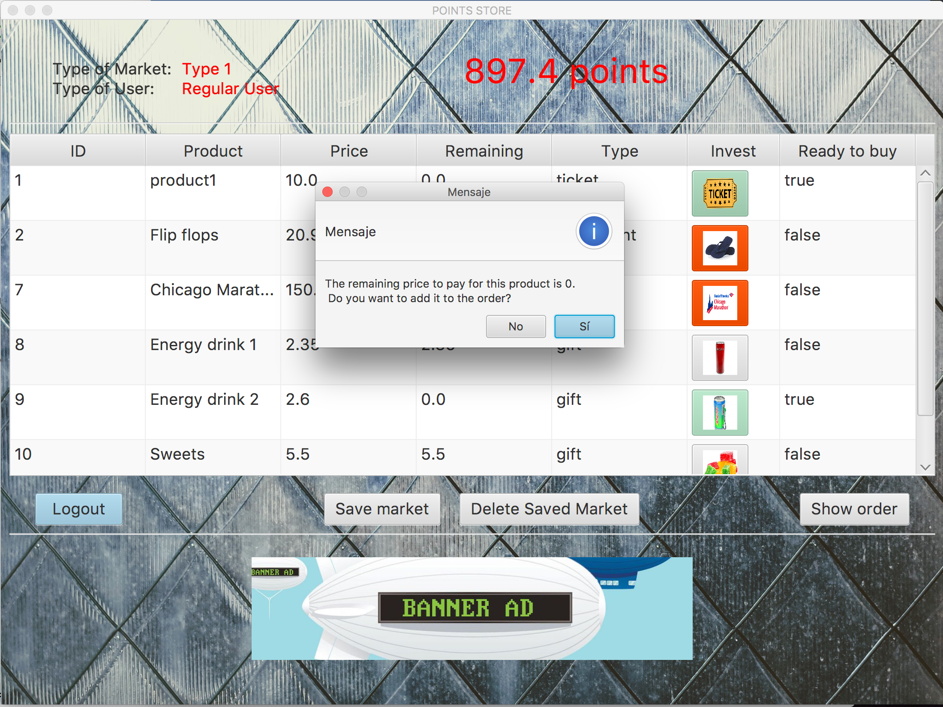

*When a product is totally paid (Remaining = 0.0) and therefore the button is in green, the user can click on the green button. Immediately, a pop up window is displayed informing the user and asking if he wants to add the product to the order. If the user answers affirmatively, the product is added to the order by id.*

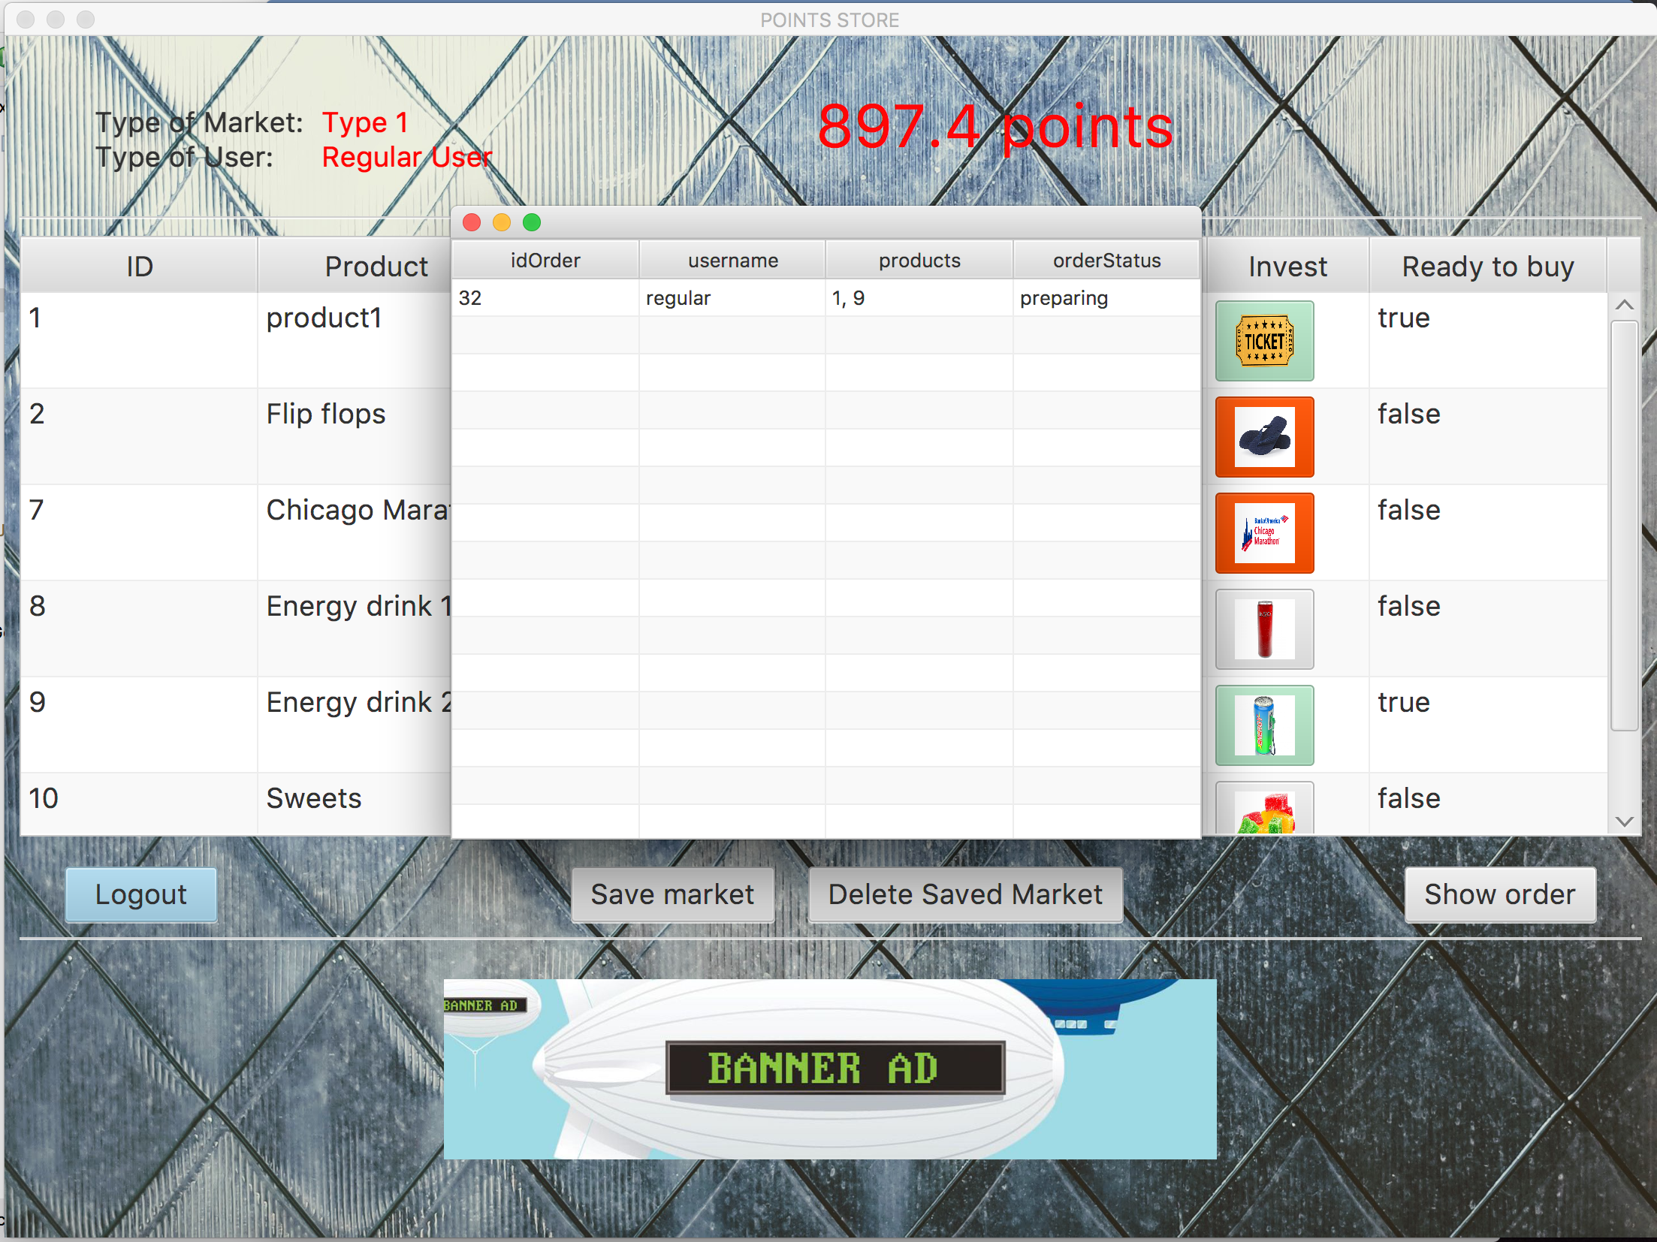

*In every moment, the user can click on “Show order”. If clicked, it displays a table window showing the current status of the order and other information about it, including the ids of the products in the order.*

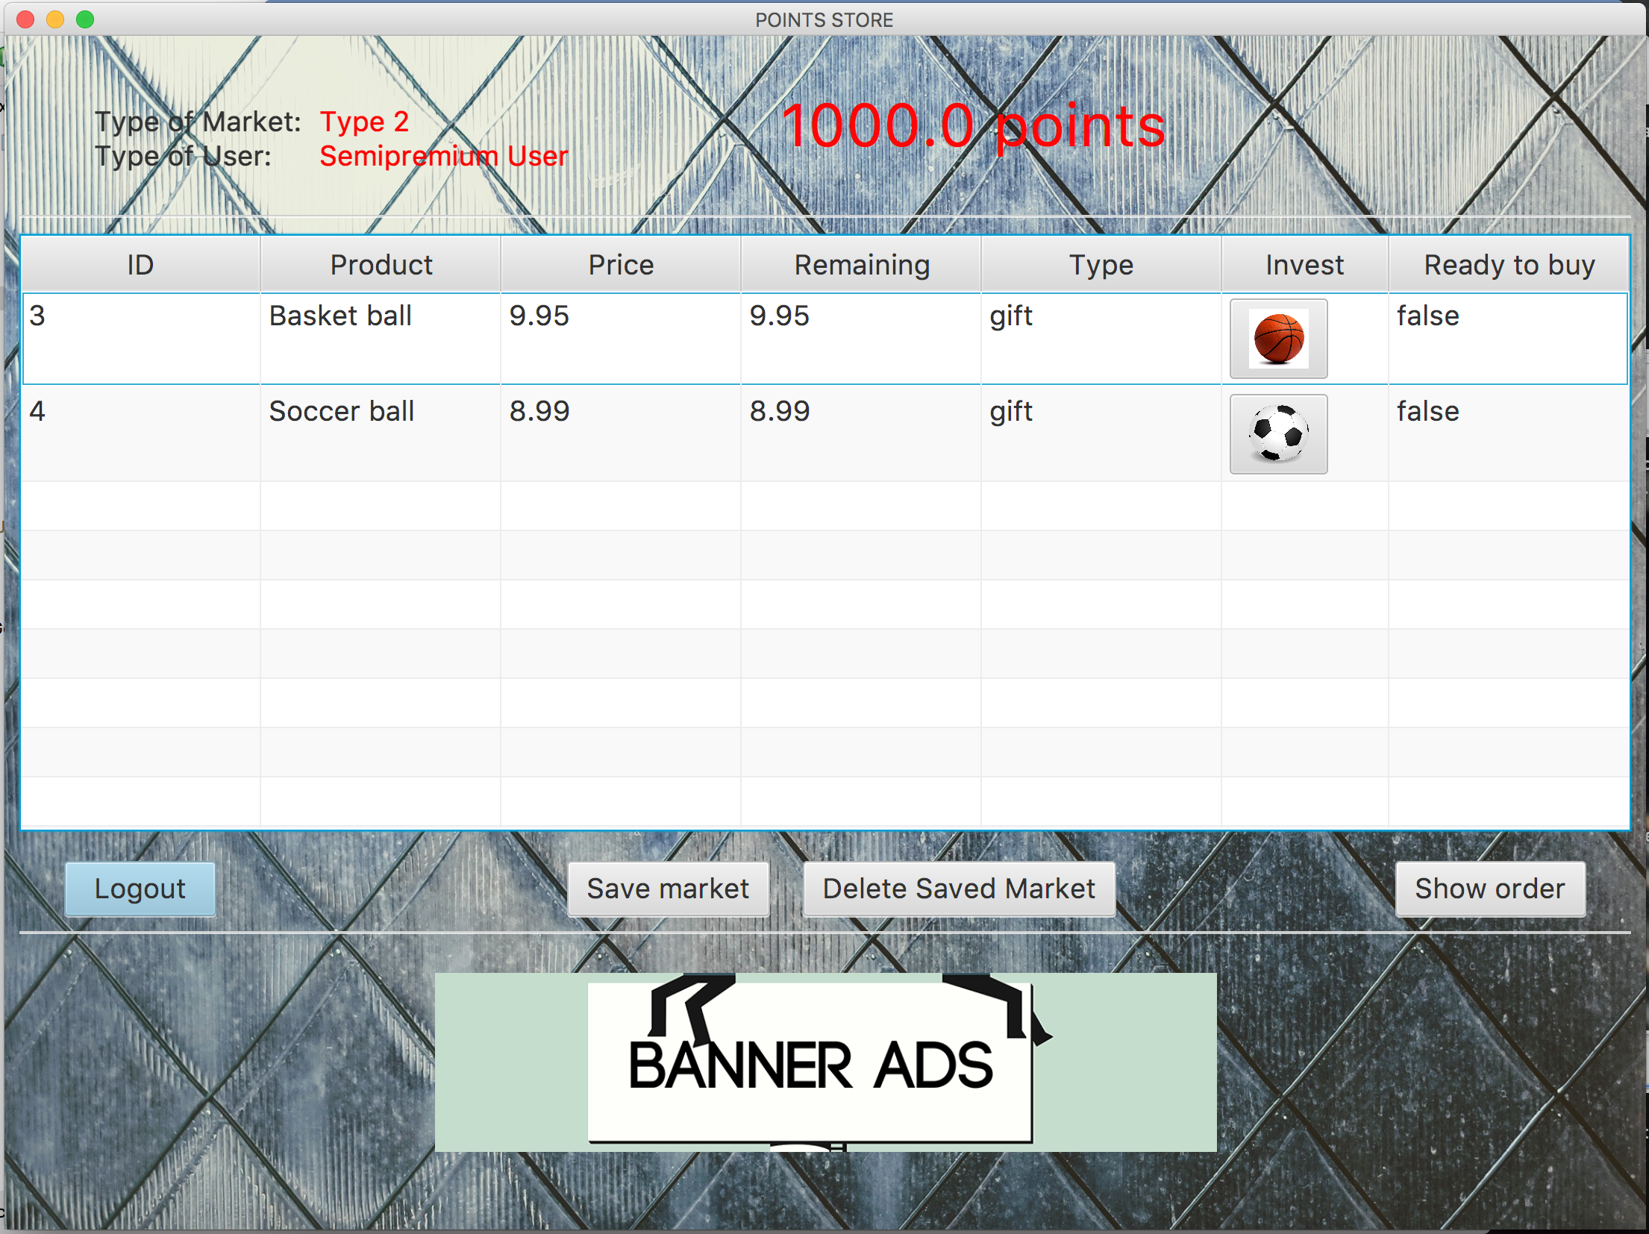

*The image above shows the window that a Semipremium User (Username: semipremium , Password: pass) sees when he logs into the system. The market is type 2.*

*A particular banner for semipremium users is shown on the bottom of the window*

*.*

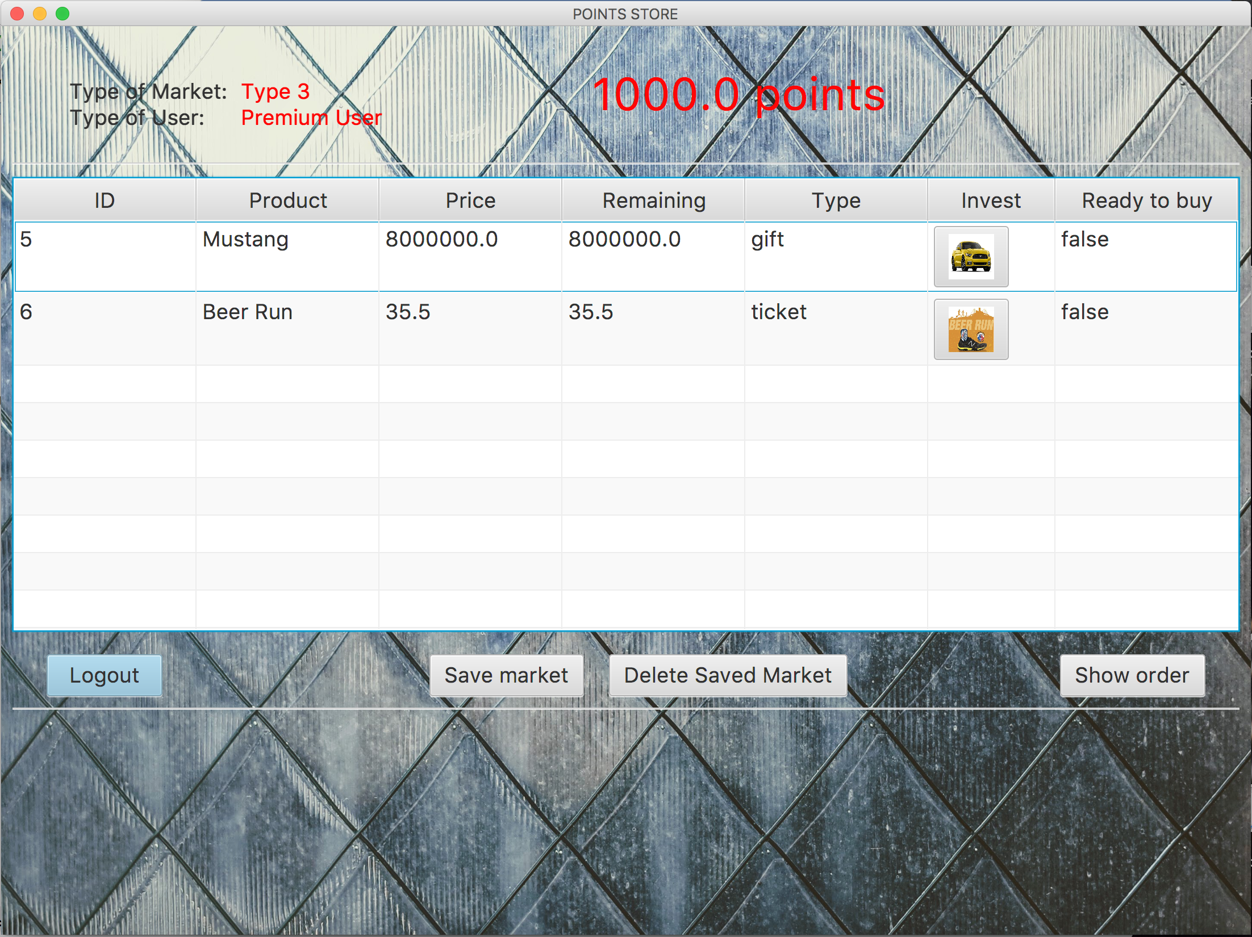

*The image above shows a Premium market. (Username: premium , Password: pass)*

*The image below shows the window seen by an Administrator (Username: admin , Password: admin). The administrator can access to all the markets available (Type 1, 2 and 3).*

*Neither the Premium User nor the Admin see ads on their screens*

